Objective: At the end of filling out this form a young person should begin to take responsibility for their behavior and understand the consequences and the effect of their behavior.

1. My behavior was_____________________________________________________
_____________________________________________________________________.
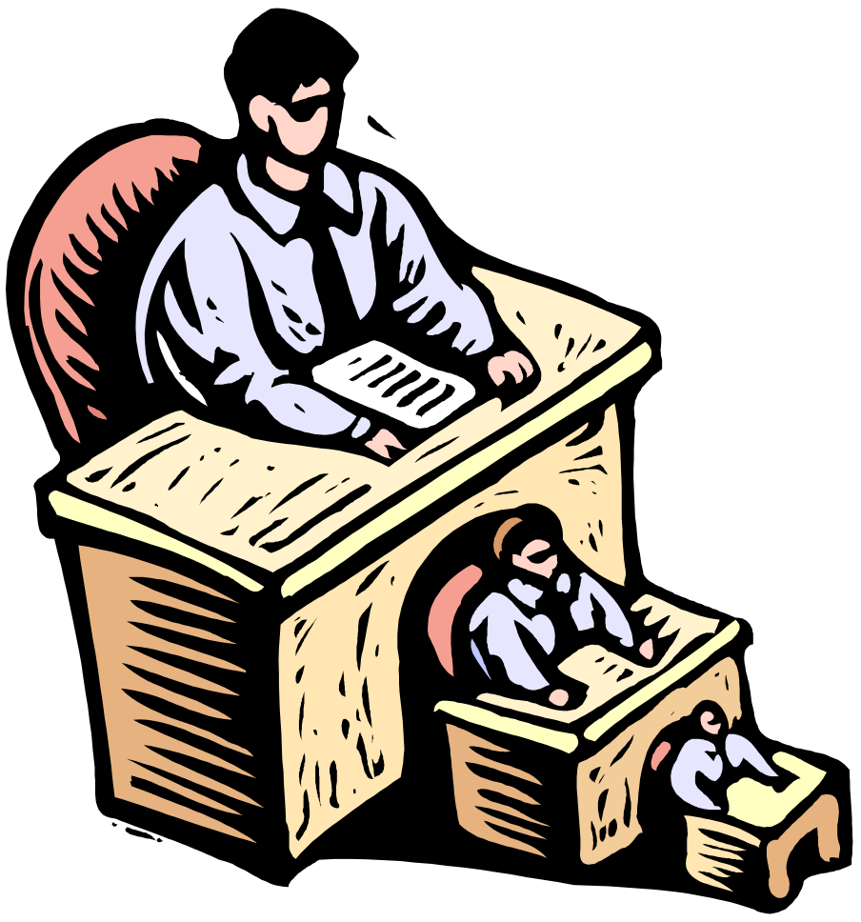
2. My behavior led to___________________________________________________
______________________________________________________________________.

3. This incident caused__________________________________________________
______________________________________________________________________.

4. The way by behavior affected my peers was _____________________________________________________________________
_____________________________________________________________________.

5. The teacher became____________________________ as a result of my behavior.

6. I could have done things differently by ______________________________
___________________________________________________________________.

7. In the future I will try to_____________________________________________
____________________________________________________________________.

